Be Wise or Beware
Pastor Rob Ketterling

Key Points:
- Be Wise and avoid debt
- Be Wise and Save
- Be Wise and live for Eternity and not for Earth
- You need the Wisdom in the Bible

Main Scripture Reference(s):
- Psalm 116:12/ Proverbs 22:7/ Matthew 16:19-20/ Proverbs 6:6-8/ Ecclesiastes 5:10/ Hebrews 13:5/ Luke 12:15/ Proverbs 22:1
Discussion Questions:
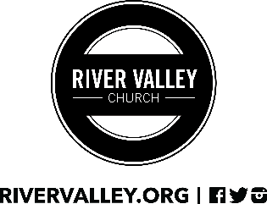
- We have Ramsey Plus available for every family in the church. Go to rivervalley.org to sign up. How do you plan on using this resource to equip you better with money management?

- What is the difference between saving and hoarding? In your life are you saving or hoarding?

- Currently are you living your life with the mind set for Eternity or are you living for the world?

- Where/ who is your source of wisdom? Are you seeking your wisdom from the bible? Are you allowing God to be your source?

- What is your next step? Is it tithing, Kingdom builders, repentance for coveting, etc?

